CURRICULUM-VITAE
Neha kumari 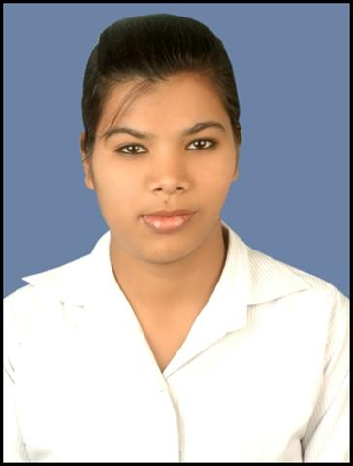

Contact 9810876940
E-Mail- moon.neha.mahalka@gmail.com

About me :- Coming from an Indian Marwari family with mild traditions. I consider my work as my faith have an optimistic attitude towards any problems encountered want to pursue a challenging career in a fast paced multi – tasking environment contribute to the growth that given me a space to enhance.

CARRER OBJECTIVES

To seek a challenging position in an esteemed organization that will allow me to efficiently utilize my skills to attain personal growth through organizational objectives.

EDUCATIONAL PARTICULARS

- Passed 10th from C.B.S.E in 2007 Jawahar Navodaya Vidyalya)
- Passed 12th from C.B.S.E in 2009.(Jawahar Navodaya Vidyalya)
- Current pursuing graduation from Maharsi Dayanand University.

EXTRA PARTICULARS

- Student Member of Indian society of Heating,Refrigerating & Air conditioning Eng.(I.S.H.R.A.E)
- Schoral of 6th National Cyber Olympiad.
- Score 84.11% in Global Mathematical test in 2005&2006(second topper of latehar district).
- Event coordinator of Esperenzzaa 2012 held in IITB.
- Currently working on a project for generation of electricity through road roller named as SPEED ROLLER ELECTRICITY GENERATION.
- VOLUNTEER OF ACREX 2012
- Industrial visit & exposure of several companies like:
(a)RISHI LASER from kundli
(b)Q H TALROS from Manesar Gurgaon

EXPERIENCE

- 4 months in Pace setters s an executive of Metlife Insurance company in international outbound process for retention & collection.
- 7 months in HT media as a Verifier & lead management.(Blended Process).

PERSONAL DETAILS

Father’s Name : Sri Naresh kumar
Mother’s Name : Mrs. Nisha Devi
Date of Birth : 20-12-1990
Gender Female
Martial status : Single
Nationality : Indian
Religion : Hindu
Language known : Hindi & English.
Category : OBC
Mark of identification : a mole in left hand.
Permanent Address : Vill – Main Road Latehar
P.O – Latehar
P.S – Latehar
Dist – Latehar (Jharkhand) 829206

DECLARATION

I herby declare that the above written particulars are correct.And I also assure you I ll give 100% if getting a chance to work with you.

Date :15 09 2015

Place : NEW DELHI

